CAHIMS/CPHIMS CEU FORM:
Time Capsule 2020: Pandemic Memoirs for Future Healthcare IT Workers

Online Conference, October - November 2020.
Below are the sessions that qualify for CPHIMS or CAHIMS continuing education (CE) hours. Check the “√” column for all sessions attended and total the number of hours earned each day. At the end of the form, total the number of hours earned for the entire event. Do not send this form to HIMSS. Retain this form for your records. You will need to provide a copy of this form if selected for an audit when renewing your certification.

Webinar | Date | Session | Hours | (√)
1 | 10/30/2020 | Five Predictions for the Future of Healthcare - Cathy Kuhn, PharmD , Director, Strategy Consulting (updox) | 1.00
2 | 10/30/2020 | Using Passive network monitors for real time visibility and security management of medical devices - Stephanie Domas, Executive Vice-President (MedSec) | 1.00
3 | 10/30/2020 | Cybersecurity in the era of COVID - Richard Staynings & Dr. Abed  (University of Denver) | 1.00
4 | 10/30/2020 | How COVID-19 Changed Telehealth: An Oncologist Perspective  Samantha Jaglowski, MD, MPH, Medical Director, Clinical & Research Informatics (The Ohio State University, James Cancer Hospital) | 1.00
5 | 10/30/2020 | Telehealth 2.0: Time to Rethink Traditional Care Models  Ujjwal Ramtekkar, MD, MBA, MPE, DFAACAP, Medical Director. Tele/Virtual Health, Behavioral Health (Nationwide Children’s Hospital | 1.00
6 | 10/30/2020 | Keynote: Healthcare Executives Guide to Ransomware Threats  Troy Ament, Chief Information Security Officer, CSO HIMSS Platinum Sponsor Fortinet | 1.00
7 | 11/06/2020 | Morning Keynote  Justin Gernot, VP Healthbox (a HIMSS Solution) | 1.00
8 | 11/06/2020 | Telehealth Panel  Robb Stillman, MA, RN, CPHIMS, OSU-The James (Moderator)  Panelist: Dori Klemanski, MS, APRN, OSU-The James  Panelist: Abigail Marker, UC Health  Panelist: Melissa Harper, UC Health | 1.00
9 | 11/06/2020 | COVID-19's Impact on Medication Access  Melissa Weant, Senior Manager, Provider Analytics (CoverMyMeds) | 1.00
10 | 11/06/2020 | Rapid Implementation of Telehealth  Brian Mitchell, CPHIMS, CHCIO, Director, Information Technology  (OSU Physicians, Inc.)  Brooke Bellamy, MBOE, SSBC, Senior Director, Patient Access  (The Ohio State University, Wexner Medical Center) | 1.00
11 | 11/06/2020 | Memoirs of a CNIO during a pandemic  Sherri Hess, CNIO, Banner Health  Sharon Kirby, MS, RN-BC, CNIO, Mayo Clinic | 1.00
12 | 11/06/2020 | CIO Panel  Alex Vaillancourt, CIO, (Moderator)  Panelist: Craig Richardville, CIO, SCL Health  Panelist: Gary Ginter, CIO, Premier Health  Panelist: Andy Lehman, CIO, Kettering Health Network. | 1.00

Total Continuing Education hours possible to earn for this event (max = 12.00) ____________

I am claiming credits to renew my: CPHIMS CAHIMS

I attest that I have attended all the sessions indicated above in their entirety.

Printed Name Certificate Number

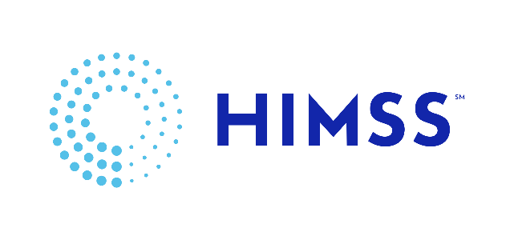
Signature ________________________________________________________ Date ________________________

