Physician Regional Event Dinner Series:
The Meaningful Use Paradigm:
Connecting Providers, Engaging Patients and Transforming Healthcare

December 11, 2014
The Global Center for Health Innovation | Cleveland, Ohio
Learning Objectives
After completing this activity, the participant should be better able to:
- Review the CMS Meaningful Use EHR Incentive Program criteria and updates required for attestation.
- Identify best practices associated with increasing patient awareness and engagement.
- Discuss local initiatives, challenges and lessons learned through an interactive discussion featuring local subject matter experts.

Target Audience
This activity has been designed to meet the educational needs of eligible providers, clinicians, office and IT staff in the ambulatory and medical practice settings, Health Center Controlled Network and Federally Qualified Health Center clinicians and staff, Regional Extension Center staff, HIT Senior executives, directors, managers and project managers currently assisting providers in achieving EHR Meaningful Use requirements
5:00 pm – 6:00 pm | Registration and Networking Reception
6:00 pm – 6:30 pm | Dinner Begins
6:30 pm – 6:45 pm | Welcome Remarks  Susan Leonard, MA, CPHIMS, Director, Professional Development, Specialty Events, HIMSS  Dan Paoletti, Chief Executive Officer, CliniSync / Ohio Health Information Partnership
6:45 pm – 7:30 pm | Overview of Meaningful Use Requirements  Robert White, MD, FAAFP, Associate Chief Medical Information Officer, Cleveland Clinic
7:30 pm – 8:15 pm | Physician and Patient Engagement  - Kathy LeBrew, Vice President for Information Technology, Patient, Physician, Innovation Systems, University Hosptials  - Barb Bungard, RN MSNI, Manager of IT Regulatory Operations, Akron Children’s Hospital
8:15 pm – 8:45 pm | EHR Meaningful Use Initiatives: A Panel Discussion Focusing on Best Practices  - Kathy LeBrew, Vice President for Information Technology, Patient, Physician, Innovation Systems, University Hospitals  - Barb Bungard, RN MSNI, Manager of IT Regulatory Operations, Akron Children’s Hospital  - Dan Paoletti, CEO, CliniSync and Ohio Health Information Partnership  - Robert White, MD, FAAFP, Associate Chief Medical Information Officer, Cleveland Clinic
8:45 pm – 9:00 pm | Closing Remarks  Susan Leonard, MA, CPHIMS, Director, Professional Development, Specialty Events, HIMSS
Thank you to our sponsor:

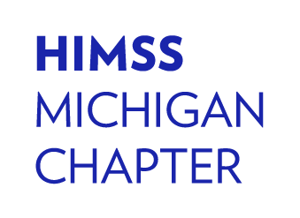
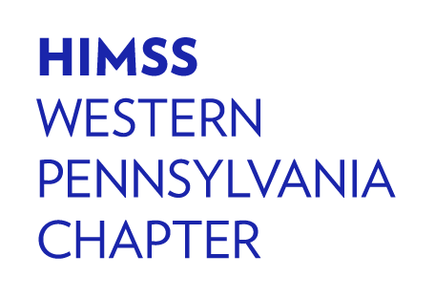
Thank you to our collaborators:
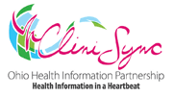

Continuing Education Information

Physician Continuing Education

Accreditation Statement
This activity has been planned and implemented in accordance with the accreditation requirements and policies of the Accreditation Council for Continuing Medical Education (ACCME) through the joint providership of Postgraduate Institute for Medicine and HIMSS. The Postgraduate Institute for Medicine is accredited by the ACCME to provide continuing medical education for physicians.

Credit Designation
The Postgraduate Institute for Medicine designates this live activity for a maximum of 2.5 AMA PRA Category 1 Credit(s)™. Physicians should claim only the credit commensurate with the extent of their participation in the activity.

Disclosure of Conflicts of Interest
Postgraduate Institute for Medicine (PIM) requires instructors, planners, managers and other individuals who are in a position to control the content of this activity to disclose any real or apparent conflict of interest (COI) they may have as related to the content of this activity. All identified COI are thoroughly vetted and resolved according to PIM policy. PIM is committed to providing its learners with high quality CME activities and related materials that promote improvements or quality in healthcare and not a specific proprietary business interest of a commercial interest.

The faculty reported the following financial relationships or relationships they or their spouse/life partner have with commercial interests related to the content of this continuing education activity:

Name of Faculty or Presenter | Reported Financial Relationship
Dan Paoletti | None
Robert White, MD | None
Kathy LeBrew | None
Barb Bungard, RN | None

The planners and managers reported the following financial relationships or relationships they or their spouse/life partner have with commercial interests related to the content of this continuing education activity: Mary Griskewicz, planner/manager for HIMSS has nothing real or apparent to disclose.

The following PIM planners and managers, Trace Hutchison, PharmD, Samantha Mattiucci, PharmD, CCMEP, and Jan Schultz, RN, MSN, CCMEP, hereby state that they or their spouse/life partner do not have any financial relationships or relationships to products or devices with any commercial interest related to the content of this activity of any amount during the past 12 months.

Disclosure of Unlabeled Use
This educational activity may contain discussion of published and/or investigational uses of agents that are not indicated by the FDA. The planners of this activity do not recommend the use of any agent outside of the labeled indications. The opinions expressed in the educational activity are those of the faculty and do not necessarily represent the views of the planners. Please refer to the official prescribing information for each product for discussion of approved indications, contraindications, and warnings.

Disclaimer
Participants have an implied responsibility to use the newly acquired information to enhance patient outcomes and their own professional development. The information presented in this activity is not meant to serve as a guideline for patient management. Any procedures, medications, or other courses of diagnosis or treatment discussed or suggested in this activity should not be used by clinicians without evaluation of their patient’s conditions and possible contraindications and/or dangers in use, review of any applicable manufacturer’s product information, and comparison with recommendations of other authorities.

Method of Participation and Request for Credit
PIM supports Green CME by offering your Request for Credit online. If you wish to receive acknowledgment for completing this activity, please complete the evaluation on www.cmeuniversity.com. On the navigation menu, click on “Find Post-test/Evaluation by Course” and search by course ID 10411. Upon registering and successfully completing the activity evaluation, your certificate will be made available immediately. Processing credit requests online will reduce the amount of paper used by nearly 100,000 sheets per year.

